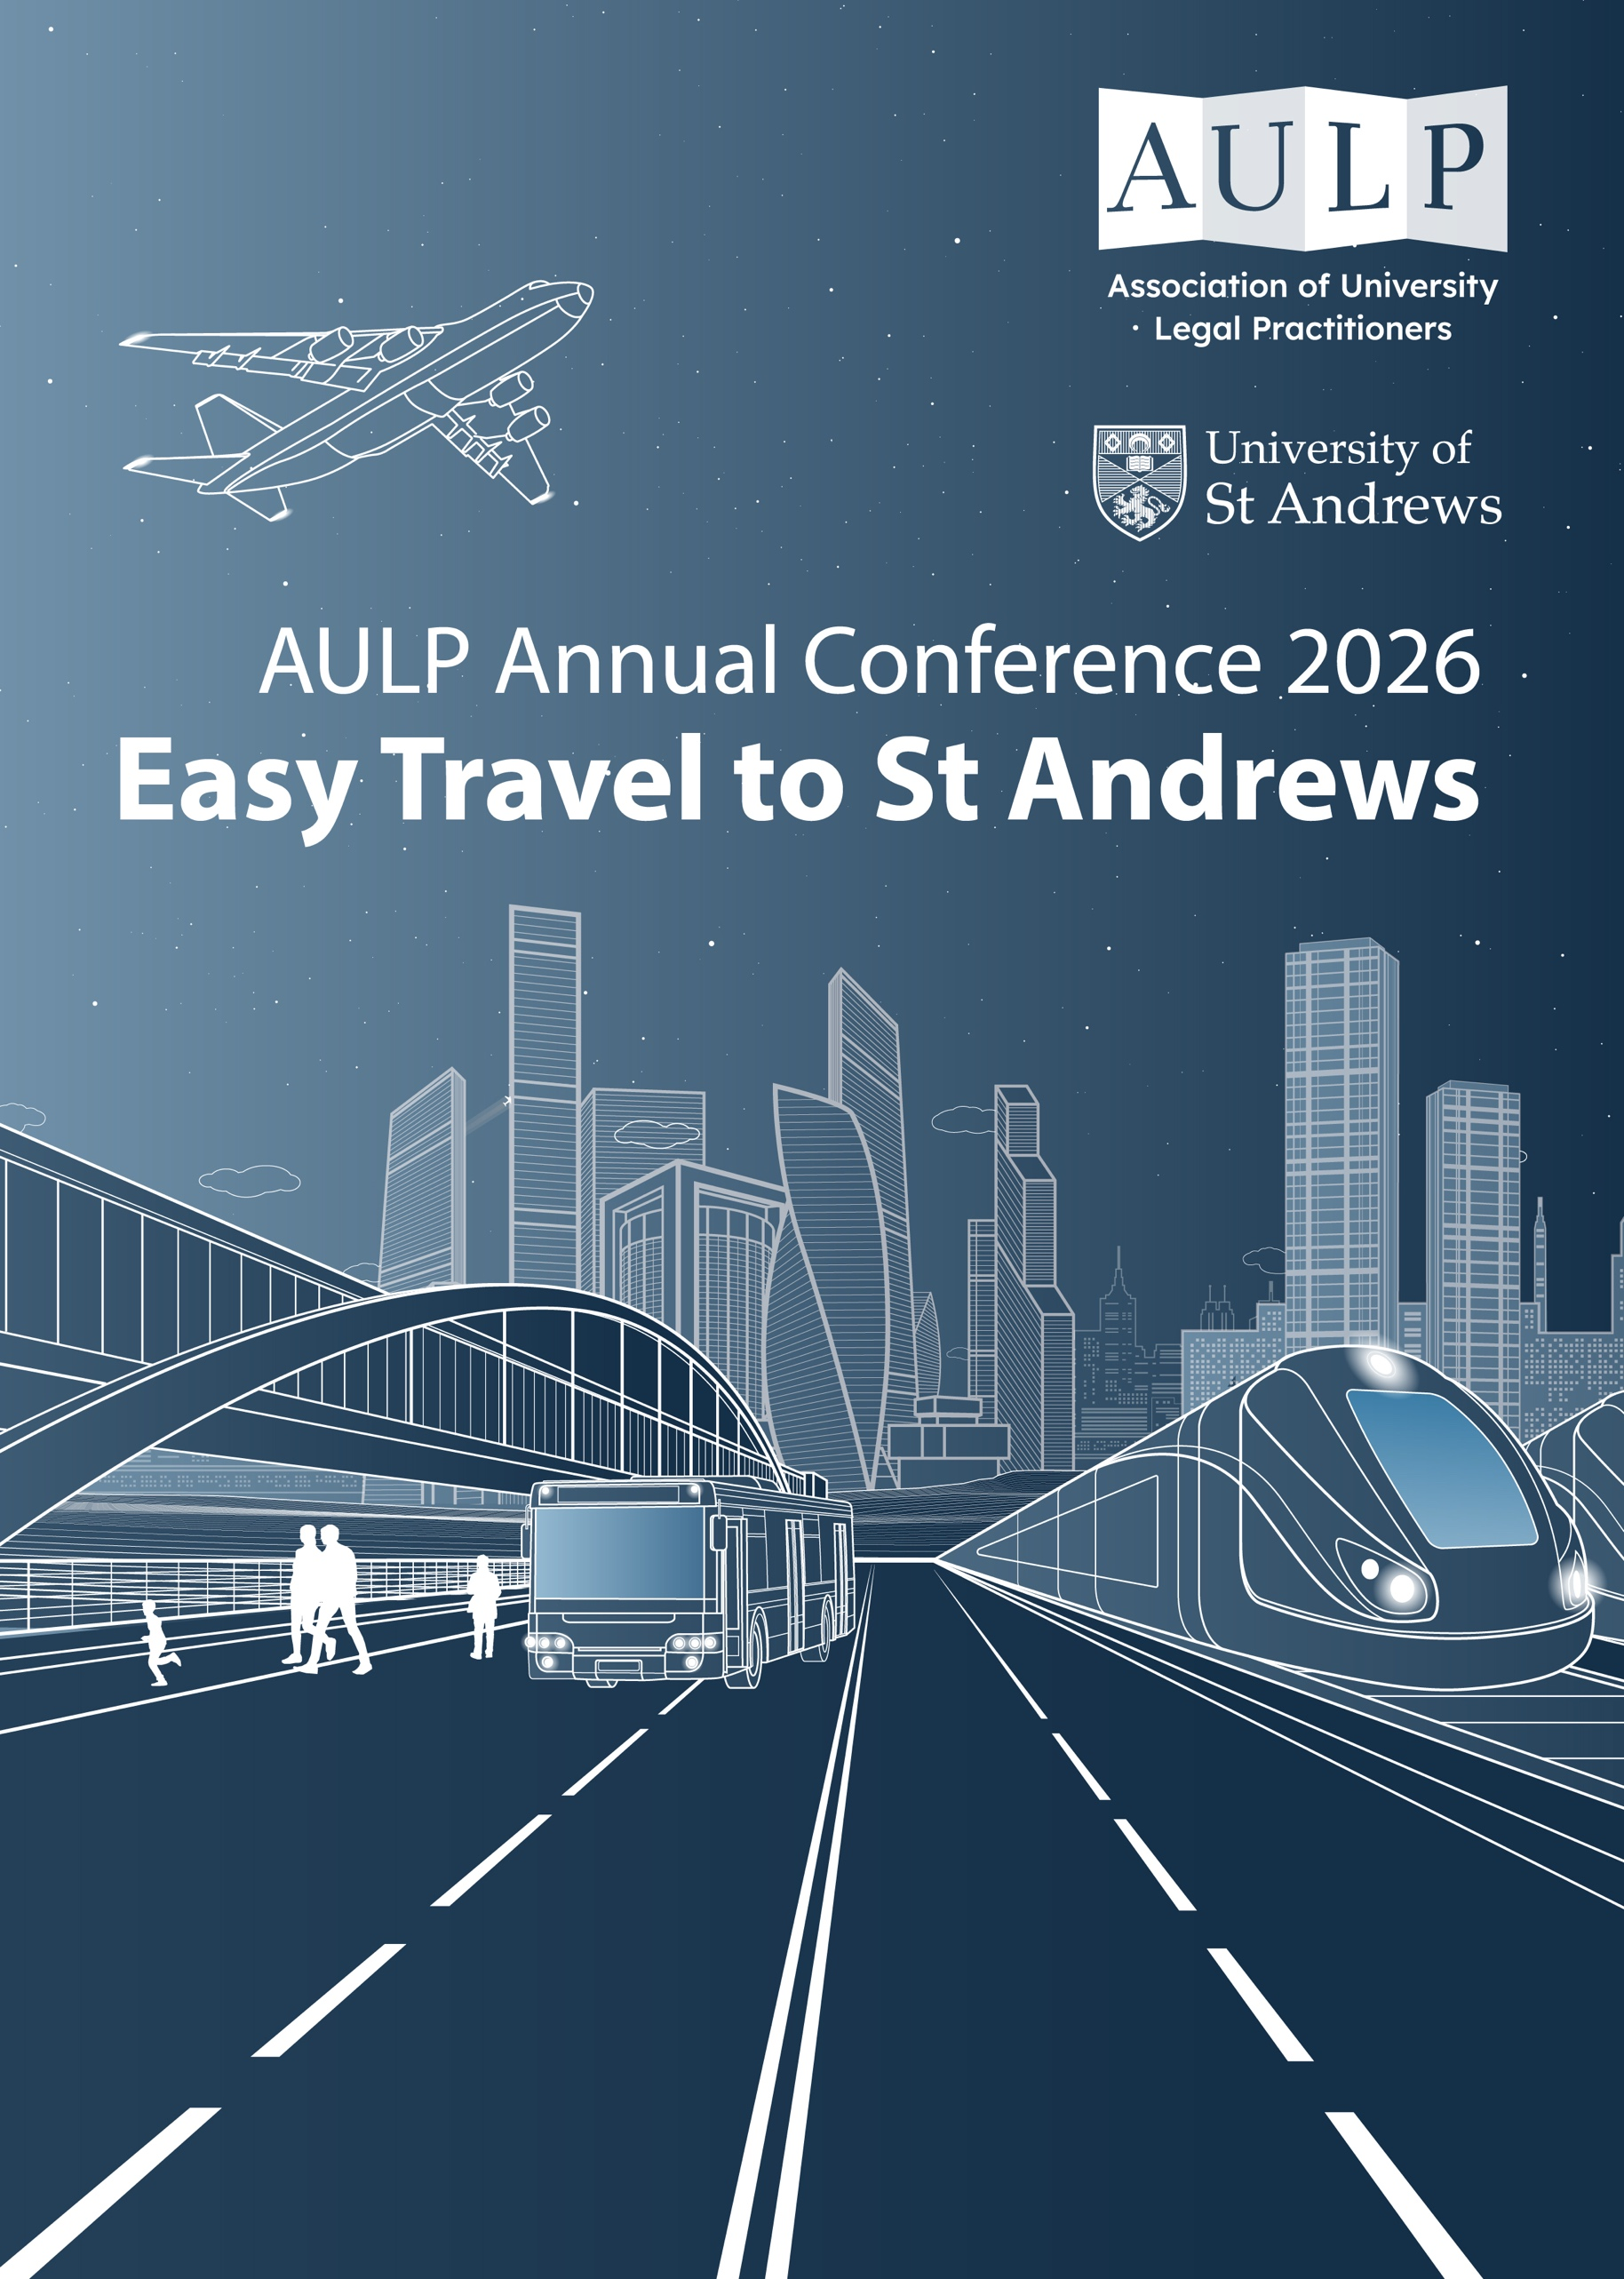

AULP 2026 Conference Travel Information Document
University of St Andrews | 17th – 19th June

The following information is to assist with your travel arrangements for attending the AULP 2026 Annual Conference at the University of St Andrews. By sharing information regarding transfers and shuttle services at this stage, we hope that you are able to make an informed choice about your travel to the event. If you have any questions, please contact harry@yourvision-events.com.


LOCATION
This year’s conference is being held at the University of St Andrews, St Andrews, Scotland, KY16 9AJ. The university halls address, where you will be staying, is located at Agnes Blackadder Hall, St Andrews, Scotland, KY16 9XW which is located 1.2km from the university campus where the conference will be taking place.


BY RAIL
DIRECT/SLEEPER TRAIN
The closest train station is Leuchars Train Station and there are regular services to Leuchars from Edinburgh, Aberdeen and Dundee. There are less regular services from Glasgow and Inverness. If you are travelling from London there are direct services to Edinburgh where you can change to get a train to Leuchars. Trains from London to Edinburgh take approx. 4 hours 30 minutes. There is also the option of a direct sleeper train from London Euston departing around 11:30pm, taking approx. 7 – 8 hours overnight on weekdays and Sundays. Please note that sleeper trains do not run on a Saturday.

To find out more information about train services visit National Rail or Scotland Rail. For more information about Sleeper services visit Sleeper Scotland.
LEUCHARS STATION
Leuchars Train Station is approx. ten to fifteen minutes from the University of St Andrews with no significant traffic. Various bus routes connect Leuchars Station and the University campus, including Stagecoach buses and bus numbers 99, F1, F2, 23A, 72, 96, 96A, 99A, 99B and 92.
Leuchars Train Station is served by Glasgow Queen Street and Edinburgh Waverly stations. Please note that when travelling to Glasgow, most connecting services arrive at Glasgow Central Station and a transfer on foot or by bus to the nearby Glasgow Queen Street station is required. When travelling to Edinburgh Waverley, connections to Leuchars are available from within the same station.
If you need to transfer between Glasgow’s two main railway stations (Glasgow Central and Glasgow Queen Street), please allow at least 30 minutes to make your connection. You can do this:

On foot: It's just a 15-minute walk between Glasgow Central and Glasgow Queen Street. The route is well signposted.

By bus: This may be a preferred option if you are carrying heavy luggage or have difficulty with walking. ScotRail, in partnership with First Glasgow, provide a frequent shuttle bus link between the 2 stations, and use of this bus is free to holders of valid train tickets. For full bus timetable information, plus a map of the walking route, please visit: http://www.scotrail.co.uk/plan-your-journey/travel-connections/train-connections

SHUTTLE SERVICE

A complimentary shuttle service will be provided from Leuchars Station to the university halls on Wednesday 17th, this will run between the hours of 16:00 – 20:00.

There will also be a transfer from the university campus to Leuchars Station on Friday 19th June, departing shortly after the conference closes at 15:00.


BY AIR
Edinburgh airport is approx. 1 hour 15 minutes from the University of St Andrews, depending on traffic. Glasgow is approx. 2 hours and 15 minutes. Both airports also have regular buses and trams to their city centres where trains run to Leuchars.

Please note that delegates are responsible for their own onward travel from both airports. If you are planning to travel to St Andrews via Edinburgh Airport and you have any concerns about your onward travel to the conference, please contact harry@yourvision-events.com, and we will do our best to support your arrangements.
BY TRAIN FROM EDINBURGH AIRPORT TO LEUCHARS:

It is advised that attendees travel to Edinburgh Waverley Station, this is located 9 miles away and is connected by the Airlink 100. The Airlink 100 (Stop D) express service runs every 12 minutes to Edinburgh city centre, stopping at St Andrew Square which is right next to the station. If travelling by taxi to Edinburgh Waverley this will take approx. 25 – 30 minutes.
BY TAXI FROM EDINBURGH AIRPORT TO ST ANDREWS

Please note that taking a walk-up taxi from the ranks outside the airports is likely to cost significantly more than pre-booking a taxi. Several companies offer pre-booked airport services (an internet search will provide the options). If you are travelling with colleagues, you may consider booking as a group for the best rates.

If you require a taxi, the recommended company to use is Braehead Radio Cars: +44 (0)141 886 1111 / (0)141 425 1111

EDINBURGH AIRPORT – MAIN DESTINATIONS AND AIRLINES (others available)
Destination | Airline (s)
Belfast City | British Airways, Aer Lingus
Belfast International | easyJet
Birmingham | easyJet
Cardiff | Loganair
Dublin | Aer Lingus, Ryanair
London (City/ Gatwick/Heathrow/Luton/Stanstead) | British Airways, easyjet
Manchester | Aer Lingus, British Airways, KLM, Ryanair

BY CAR
There is parking available on campus and the parking is free. If you have a query about any aspect of car parking on campus, please contact parking support, +44 (0) 1334 467198.
If approaching from Glasgow, Edinburgh or Aberdeen take the M90 to Junction 8 and exit for the A91/A92 toward St Andrews. The University is well signed from the town entrances.

- From Aberdeen A90, M90, A91/A92.
- From Edinburgh A720, M90, A91/A92.
- From Glasgow M8, M9, M90, A91/A92.

We encourage conference attendees to use the most sustainable mode(s) of transport where possible.

